We generally have four kind of environments,

1. Development
2. Testing
3. Staging
4. Production

The environment variable is defined in the launchsettings,json file.

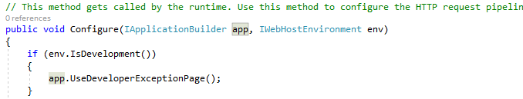

From the Configure method, the IwebHostEnvironment variable gets the environment from the json file. 